IVASS Regulation 38-2018 Compliance for Log360
Tagline: Support Italian insurance IT governance and outsourcing compliance with log monitoring from Log360.

Overview
The IVASS Regulation 38/2018 Compliance extension for Log360 supports Italian insurance undertakings in meeting the IT governance, information security, and outsourcing oversight requirements established by the Italian insurance supervisory authority (IVASS).
Log360 collects and analyzes logs from insurance policy systems, cloud platforms, outsourced service environments, and network infrastructure, providing security teams with visibility into critical IT events. Compliance teams can monitor access to policyholder data, detect anomalies, and generate audit evidence for IVASS inspections.

Key Features
- Generate IVASS Regulation 38/2018-aligned audit reports covering IT governance controls, access management, and information security incident monitoring.
- Monitor user access to sensitive insurance data and detect unauthorized system changes across internal and outsourced IT environments.
- Configure real-time alerts for security events relevant to IVASS requirements including privilege escalations and unauthorized administrative actions.
- Export compliance documentation in PDF and CSV formats for IVASS supervisory reviews and internal insurance IT governance.
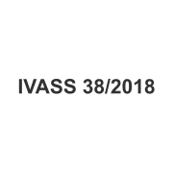
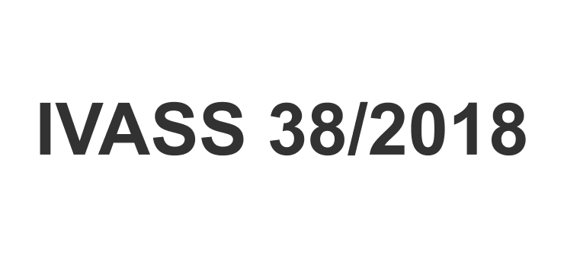

Screenshots
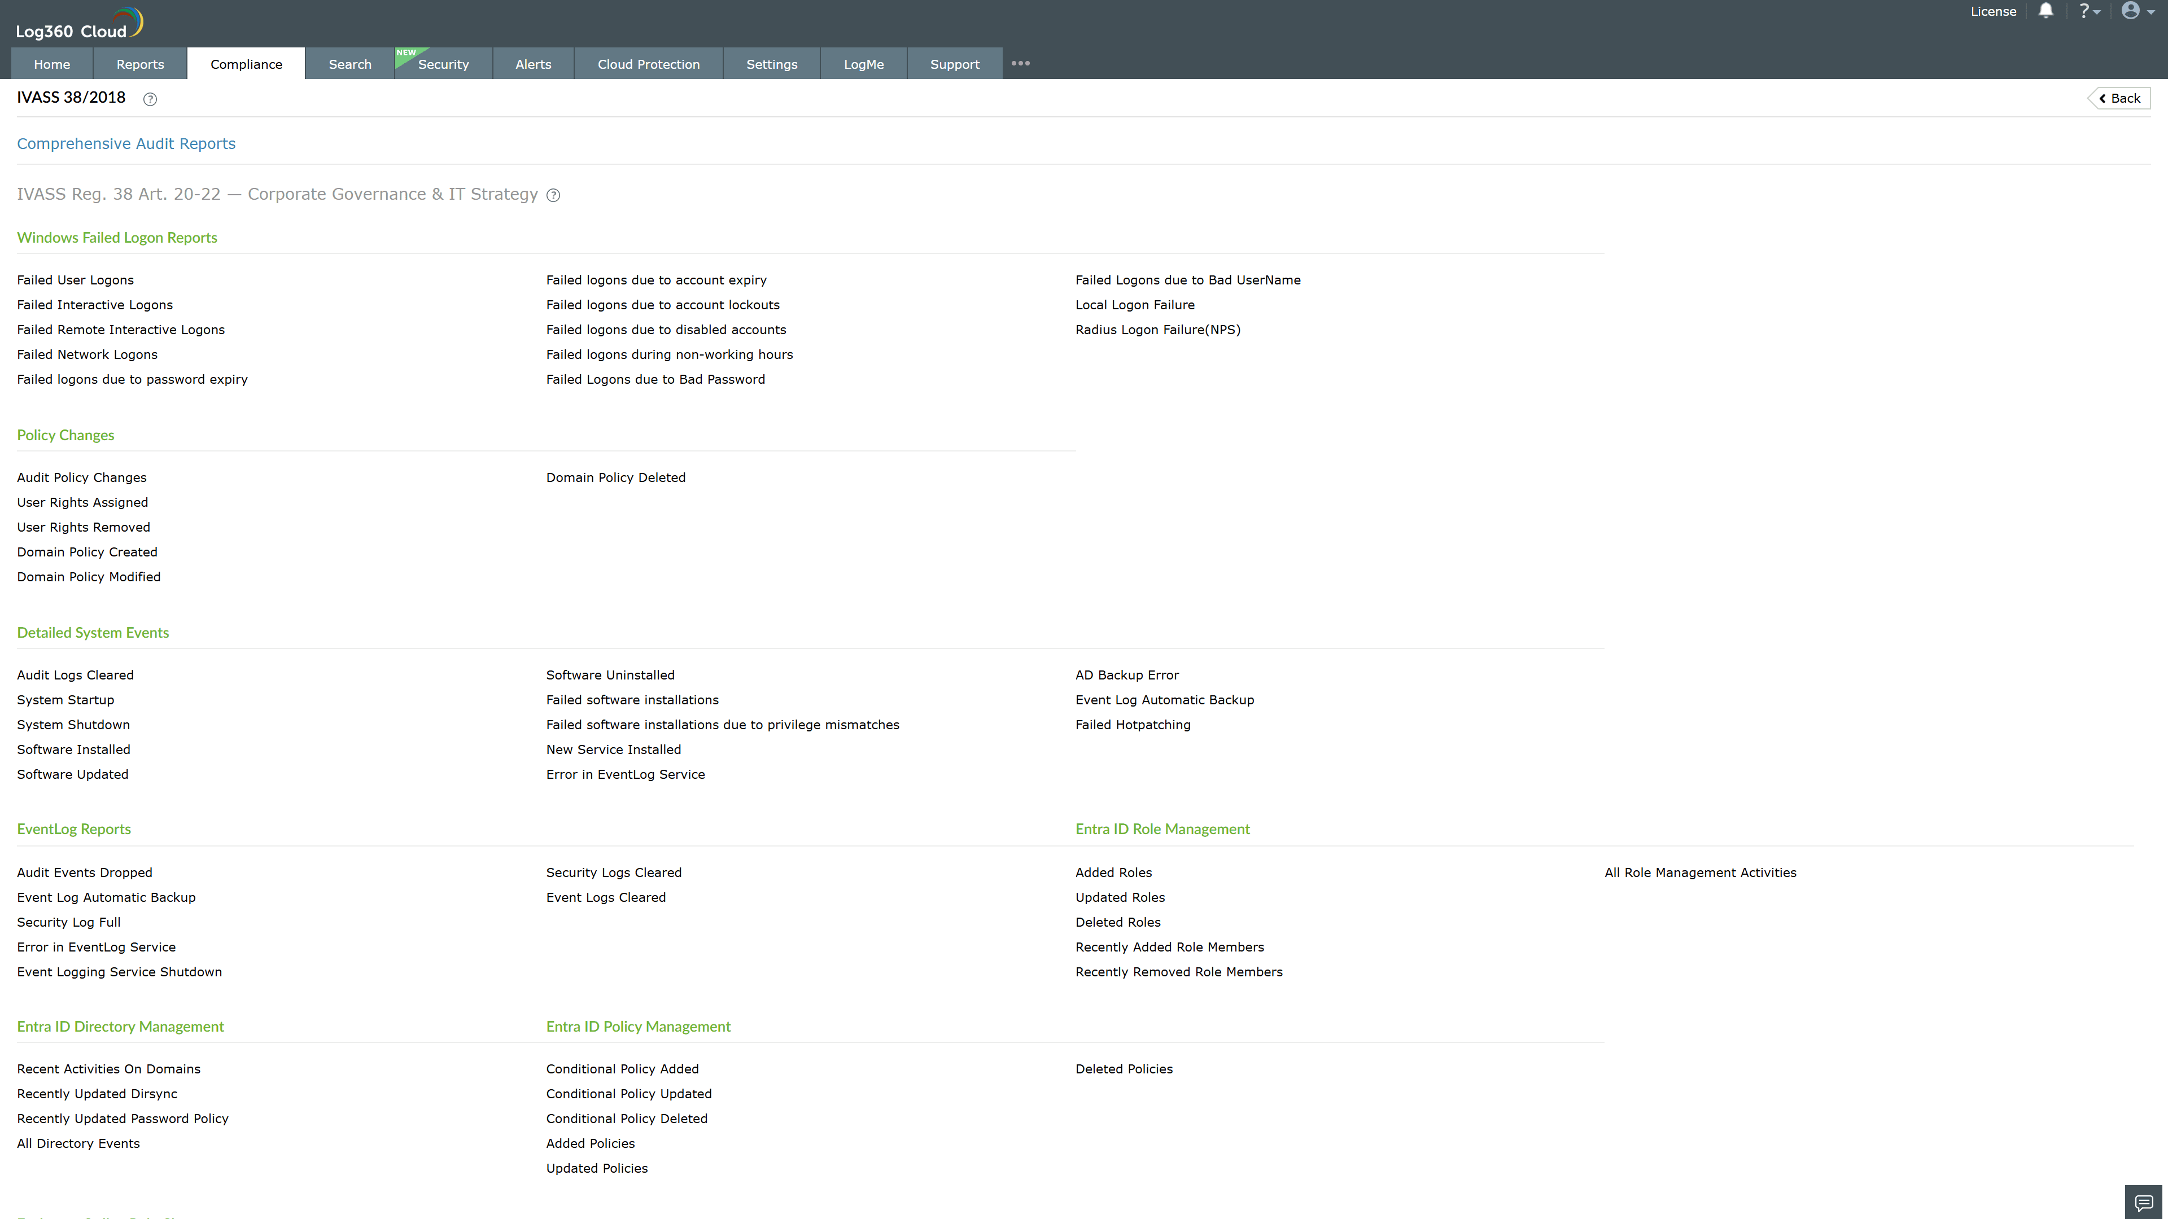
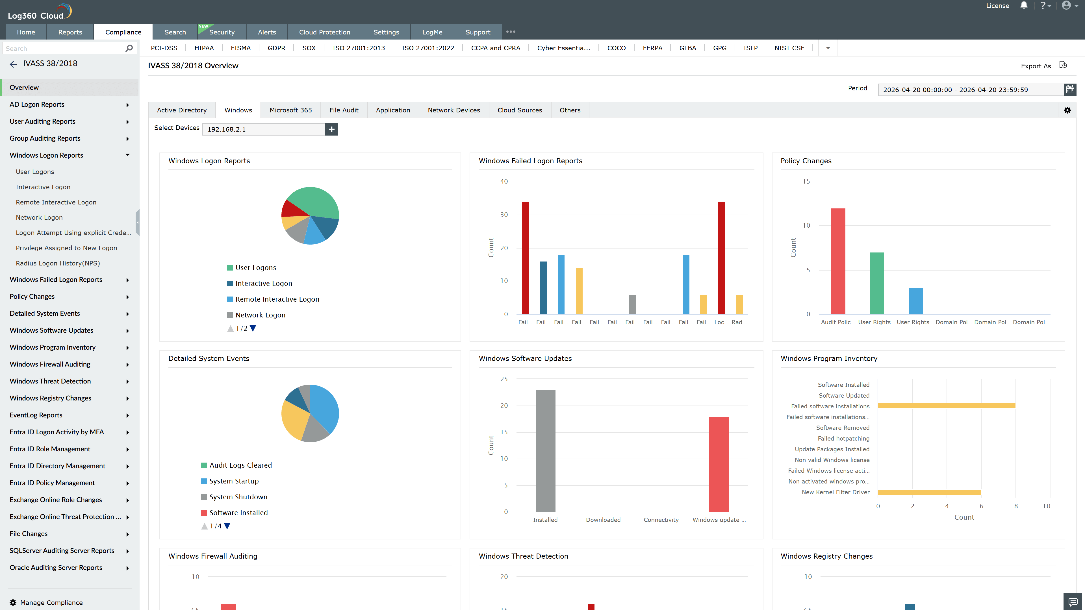
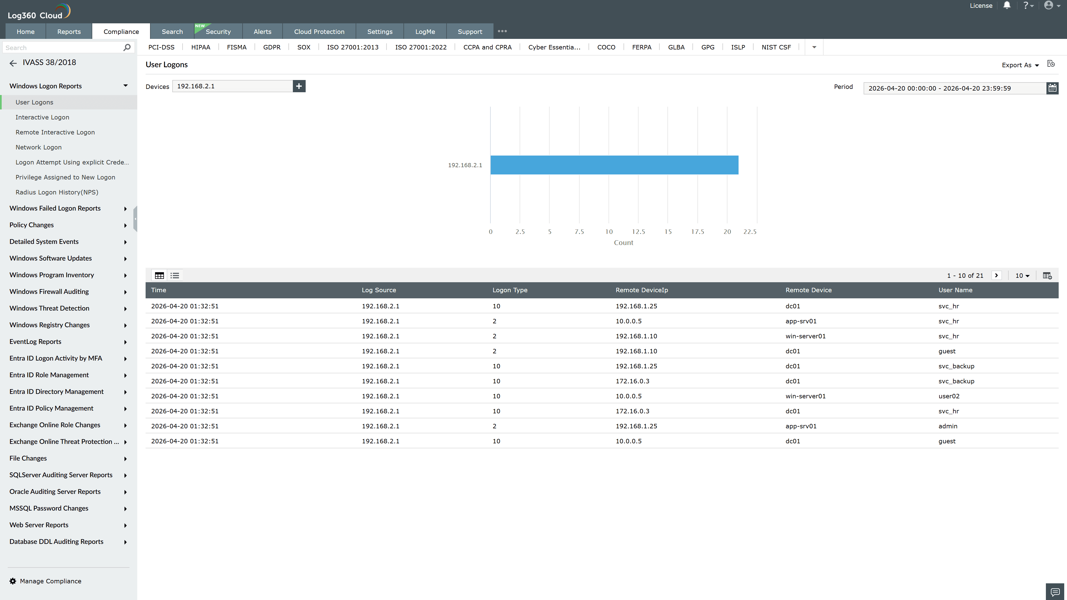
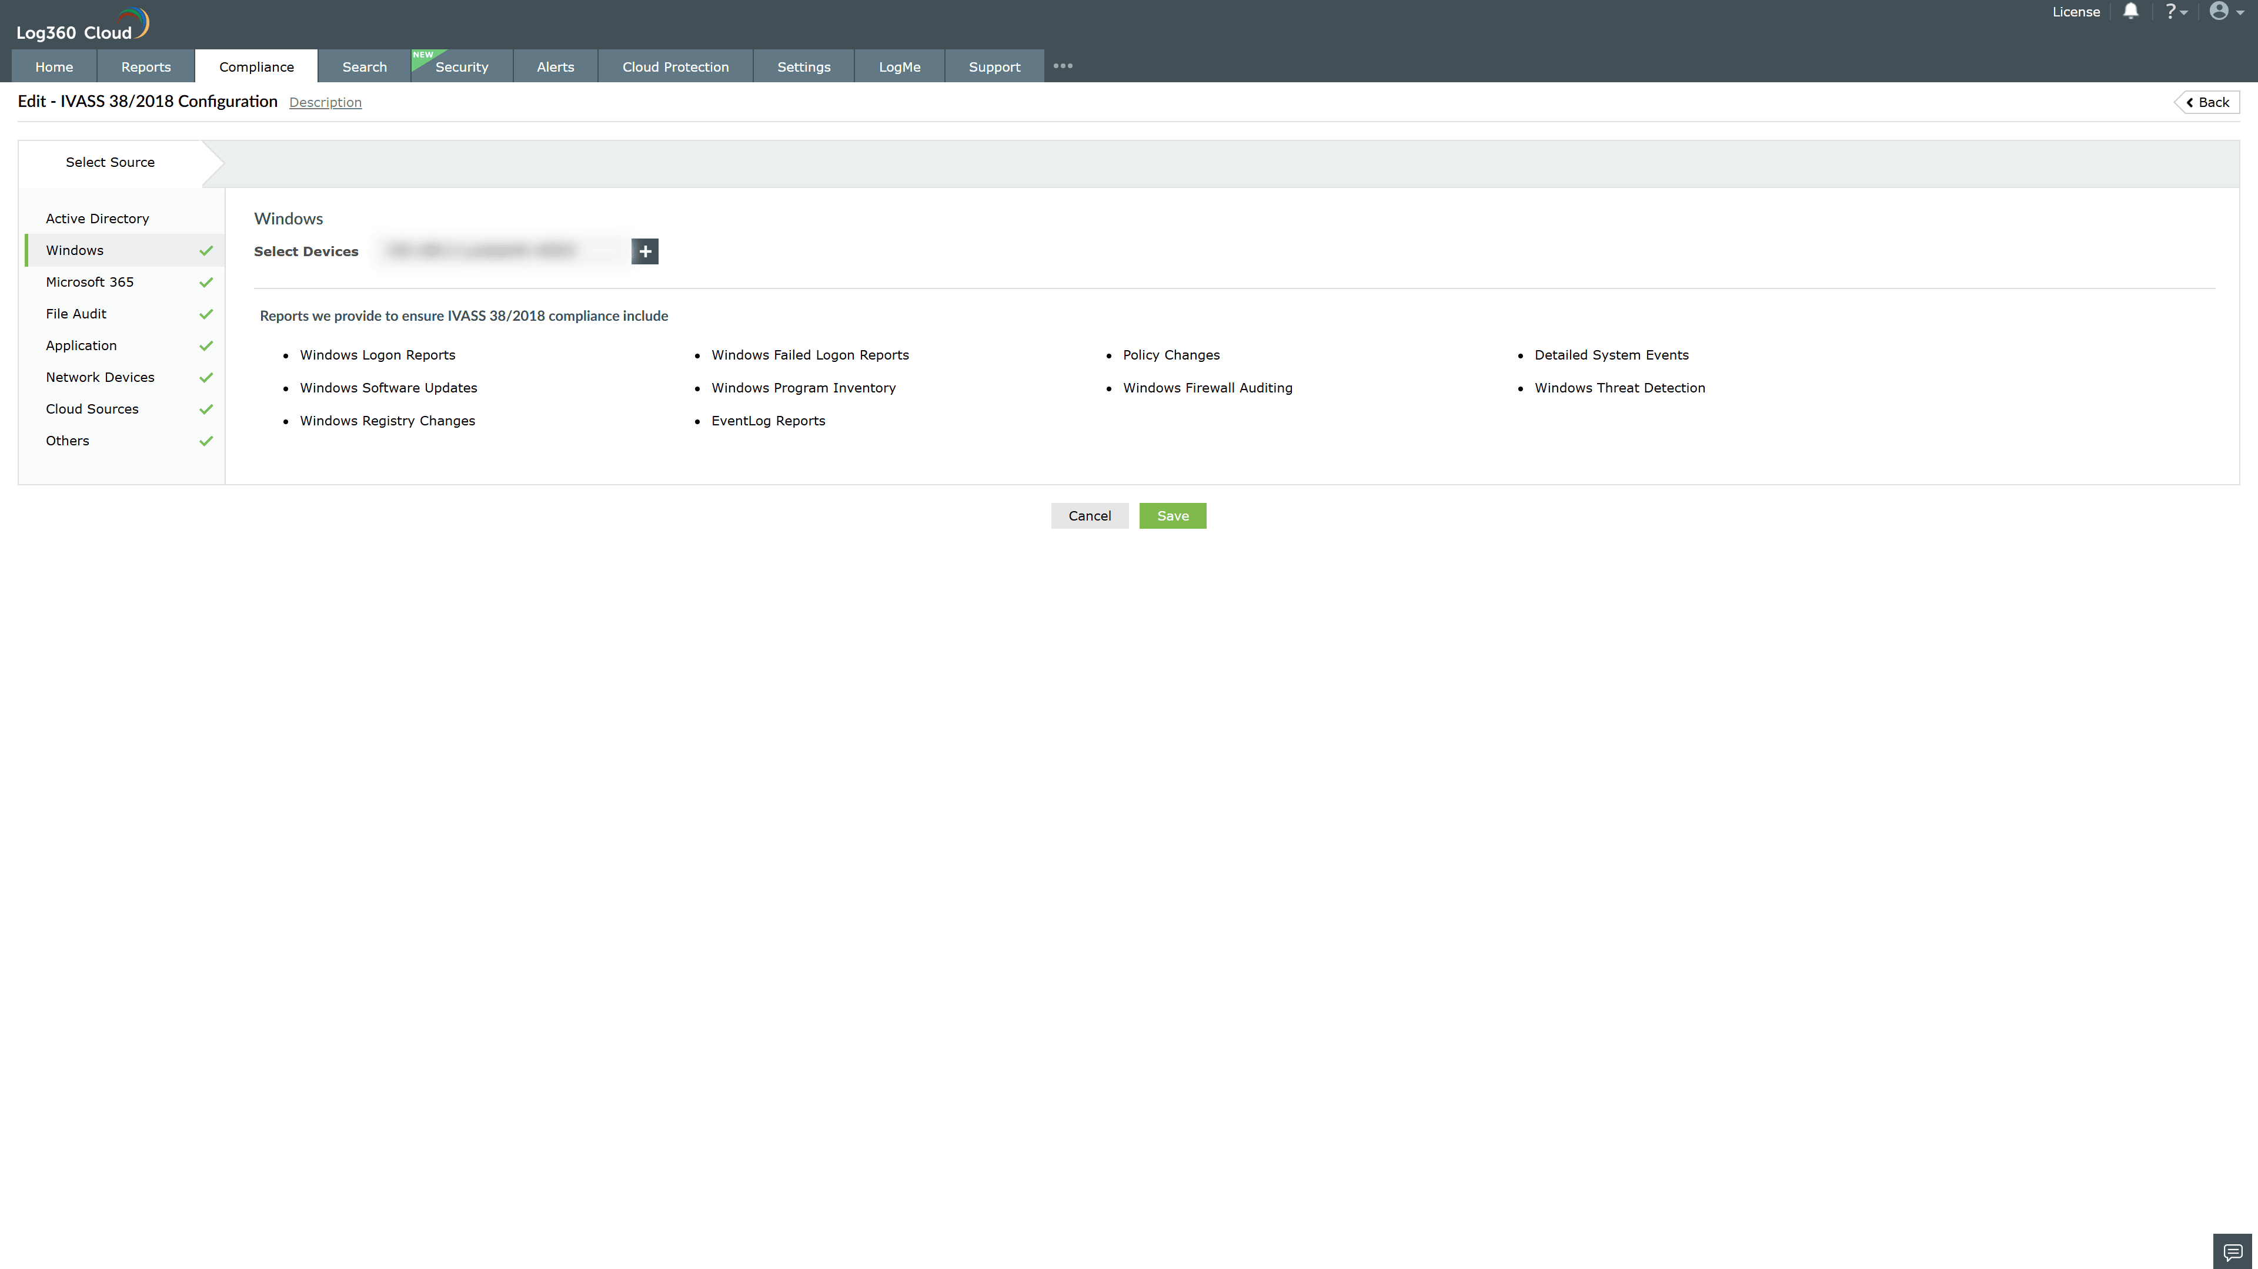

Valid Submission : Yes
Supported Editions : Free, Basic, Standard, Professional, MSSP
Help Document : https://www.manageengine.com/log-management/help/integrations/compliance-extensions.html
Help Video : Not provided
Tags : Log360, Compliance, Privacy monitoring, Data privacy, Regulatory compliance
Supported DCs : US, IN, JP, CA, AU, UK and EU
Privacy Policy:
Terms of Service:
Release Notes:
Predefined reports for the IVASS Regulation 38/2018 Compliance

